Superset ID-6363144

**“VIEWS”**

-- Cleanup: Drop views if they exist

IF OBJECT_ID('vw_EmployeeReport', 'V') IS NOT NULL DROP VIEW vw_EmployeeReport;

IF OBJECT_ID('vw_EmployeeAnnualSalary', 'V') IS NOT NULL DROP VIEW vw_EmployeeAnnualSalary;

IF OBJECT_ID('vw_EmployeeFullName', 'V') IS NOT NULL DROP VIEW vw_EmployeeFullName;

IF OBJECT_ID('vw_EmployeeBasicInfo', 'V') IS NOT NULL DROP VIEW vw_EmployeeBasicInfo;

-- Cleanup: Drop tables if they exist

IF OBJECT_ID('Employees', 'U') IS NOT NULL DROP TABLE Employees;

IF OBJECT_ID('Departments', 'U') IS NOT NULL DROP TABLE Departments;

-- Step 1: Create Departments table

CREATE TABLE Departments (

DepartmentID INT PRIMARY KEY,

DepartmentName VARCHAR(100)

);

-- Step 2: Create Employees table

CREATE TABLE Employees (

EmployeeID INT PRIMARY KEY,

FirstName VARCHAR(50),

LastName VARCHAR(50),

DepartmentID INT FOREIGN KEY REFERENCES Departments(DepartmentID),

Salary DECIMAL(10, 2),

JoinDate DATE

);

-- Step 3: Insert sample data

INSERT INTO Departments VALUES

(1, 'HR'),

(2, 'Finance'),

(3, 'IT'),

(4, 'Marketing');

INSERT INTO Employees VALUES

(1, 'John', 'Doe', 1, 5000.00, '2020-01-15'),

(2, 'Jane', 'Smith', 2, 6000.00, '2019-03-22'),

(3, 'Michael', 'Johnson', 3, 7000.00, '2018-07-30'),

(4, 'Emily', 'Davis', 4, 5500.00, '2021-11-05');

GO

-- Exercise 1: Simple View - vw_EmployeeBasicInfo

CREATE VIEW vw_EmployeeBasicInfo AS

SELECT

e.EmployeeID,

e.FirstName,

e.LastName,

d.DepartmentName

FROM Employees e

JOIN Departments d ON e.DepartmentID = d.DepartmentID;

GO

-- Test it

SELECT * FROM vw_EmployeeBasicInfo;

GO

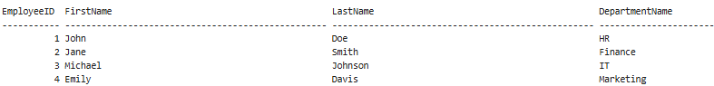

**EXERCISE 2**

CREATE VIEW vw_EmployeeFullName AS

SELECT

EmployeeID,

FirstName + ' ' + LastName AS FullName

FROM Employees;

GO

-- Test it

SELECT * FROM vw_EmployeeFullName;

GO

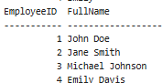

EXERCISE 3

CREATE VIEW vw_EmployeeAnnualSalary AS

SELECT

EmployeeID,

Salary,

Salary * 12 AS AnnualSalary

FROM Employees;

GO

-- Test it

SELECT * FROM vw_EmployeeAnnualSalary;

GO

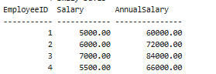

EXERCISE 4

CREATE VIEW vw_EmployeeReport AS

SELECT

e.EmployeeID,

e.FirstName + ' ' + e.LastName AS FullName,

d.DepartmentName,

e.Salary * 12 AS AnnualSalary,

e.Salary * 12 * 0.10 AS Bonus

FROM Employees e

JOIN Departments d ON e.DepartmentID = d.DepartmentID;

GO

-- Test it

SELECT * FROM vw_EmployeeReport;

